Blender

Game Engine
Python
Manual
by
Christopher Andrew Topalian

Copyright 2000-2024
All Rights Reserved

Dedicated
to
God the Father
Table of Contents
Search Google for: Blender Game Engine 4
Download: Blender Game Engine 5
System Console 6
Open Text Editor to Edit Python Scripts 7
Name Script and Type our Python Code 8
Save Python Script 9
Connect our Python Script to our Cube 11
How to Start the Blender Game Engine 12
# show_object_name.py 13
Zooming in, we see the Always Sensor 14
# show_name.py 15
# show_name_with_label.py 16
# get_position.py 17
# get_position_x.py 18
# get_position_y.py 19
# get_position_z.py 20
# get_position_x_y_z.py 21
# move_object_to_position_x_y_z.py 22
# move_object_to_position_vector_xyz.py 23
# move_object_in_increments.py 24
# get_sensor.py 26
# show_mouse_arrow.py 28
# show_mouse_arrow_at_position.py 29
# world_position_rotation.py 30
# text_change.py 31
# text_change_other_object.py 32
# property_change.py 35
# Move Object Using Python Near Sensor equivalent 38
# player_motion_controls.py 41
True Artificial Intelligence System 43

Search Google for: Blender Game Engine
Search for: Blender Game Engine
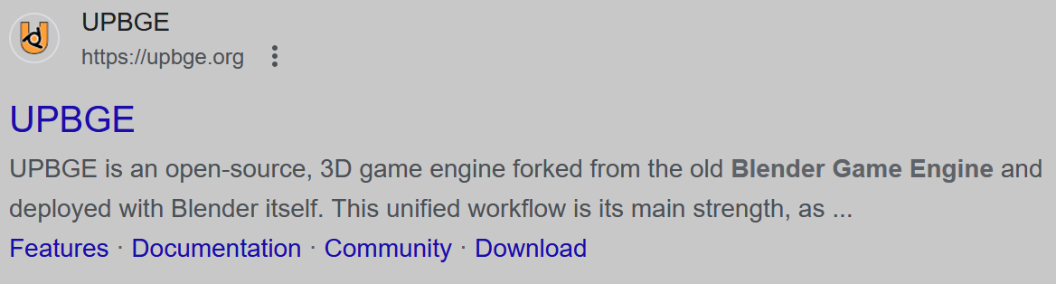
Left Click: Download
https://upbge.org/#/download

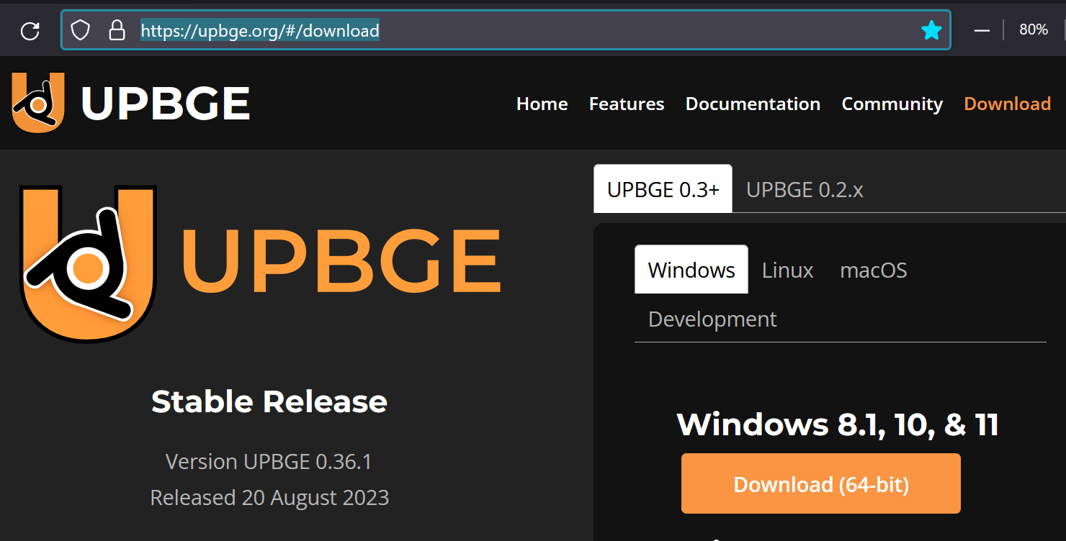
Download: Blender Game Engine

Left Click: Download (64-bit)

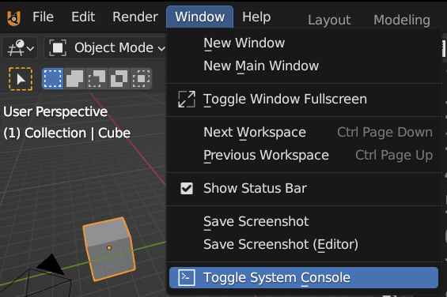
System Console

Left Click on: Window menu
Left Click on: Toggle System Console
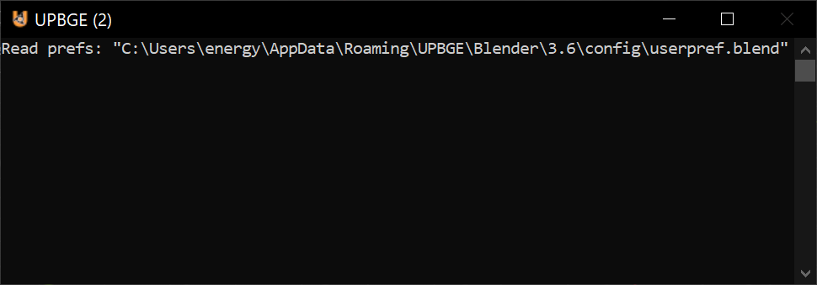

Open Text Editor to Edit Python Scripts
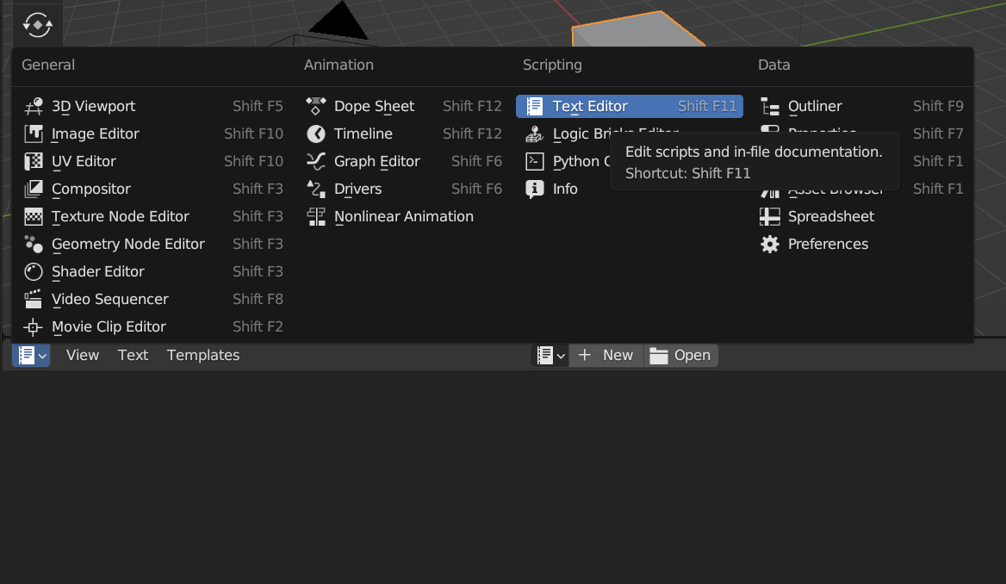
Text Editor
Left Click: Editor Type Button
Left Click: Text Editor
Left Click: New

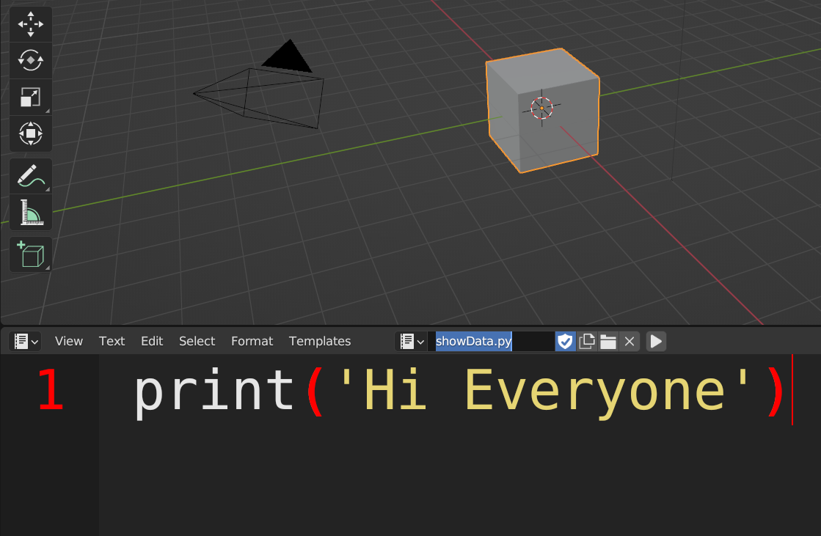
Name Script and Type our Python Code

Save Python Script

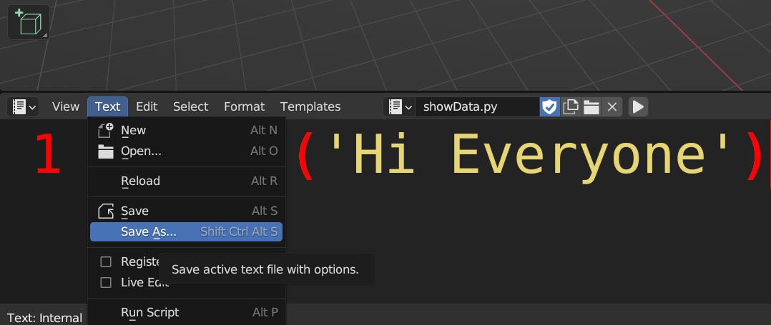
Notice that our Python script has no spaces in the name and that the Python script name ends with the .py extension type, showData.py

We Make a New Folder and Name it, scripts
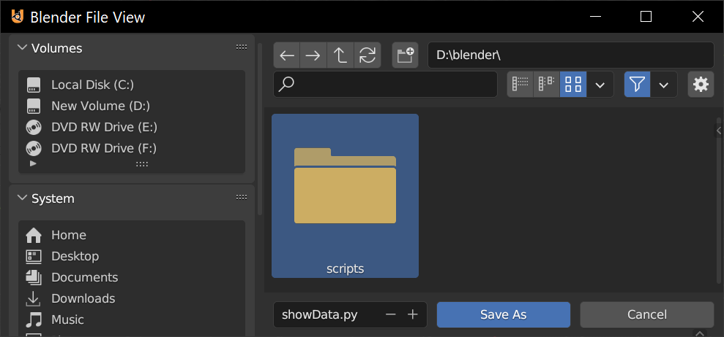

Double Left Click: scripts folder
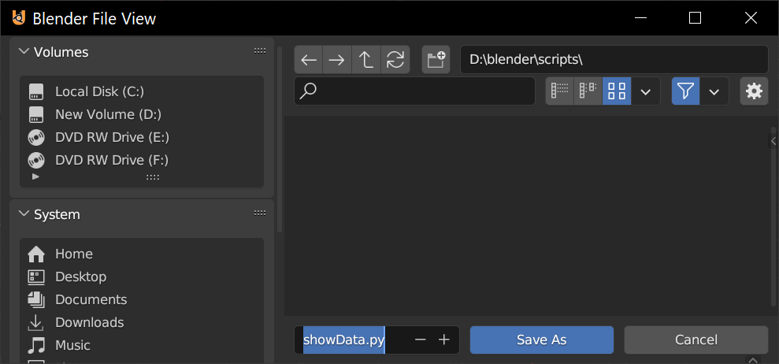
-

Left Click: Save As

Our Python script named scriptData.py
is now saved in our scripts folder.

Connect our Python Script to our Cube

We add an: Always Actuator and Python Controller
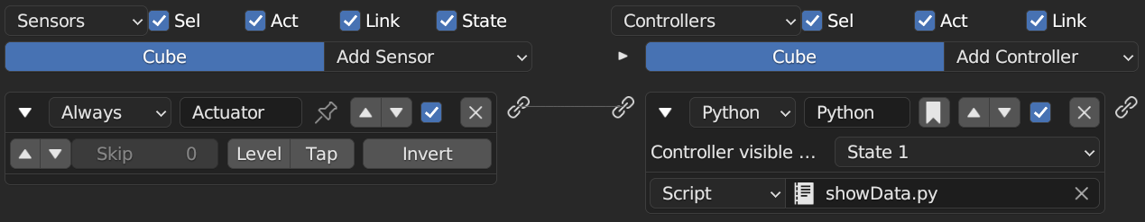
We have set this Always Actuator to trigger only one time. We choose the script that will trigger by using the Script drop down menu, of the Python Controller.

When we start the game engine it will state
Hi Everyone in the Blender Console
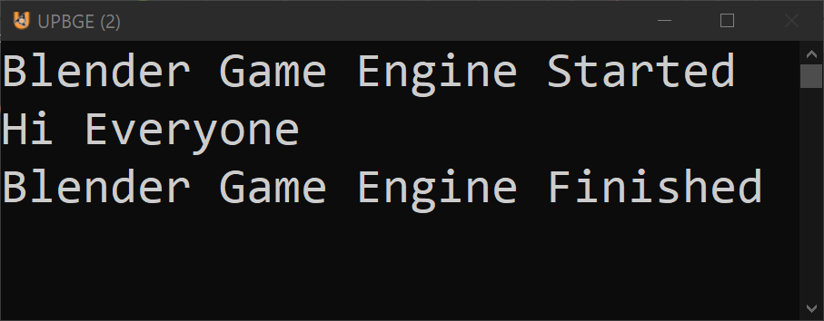

How to Start the Blender Game Engine

We place our mouse arrow in: 3d Window
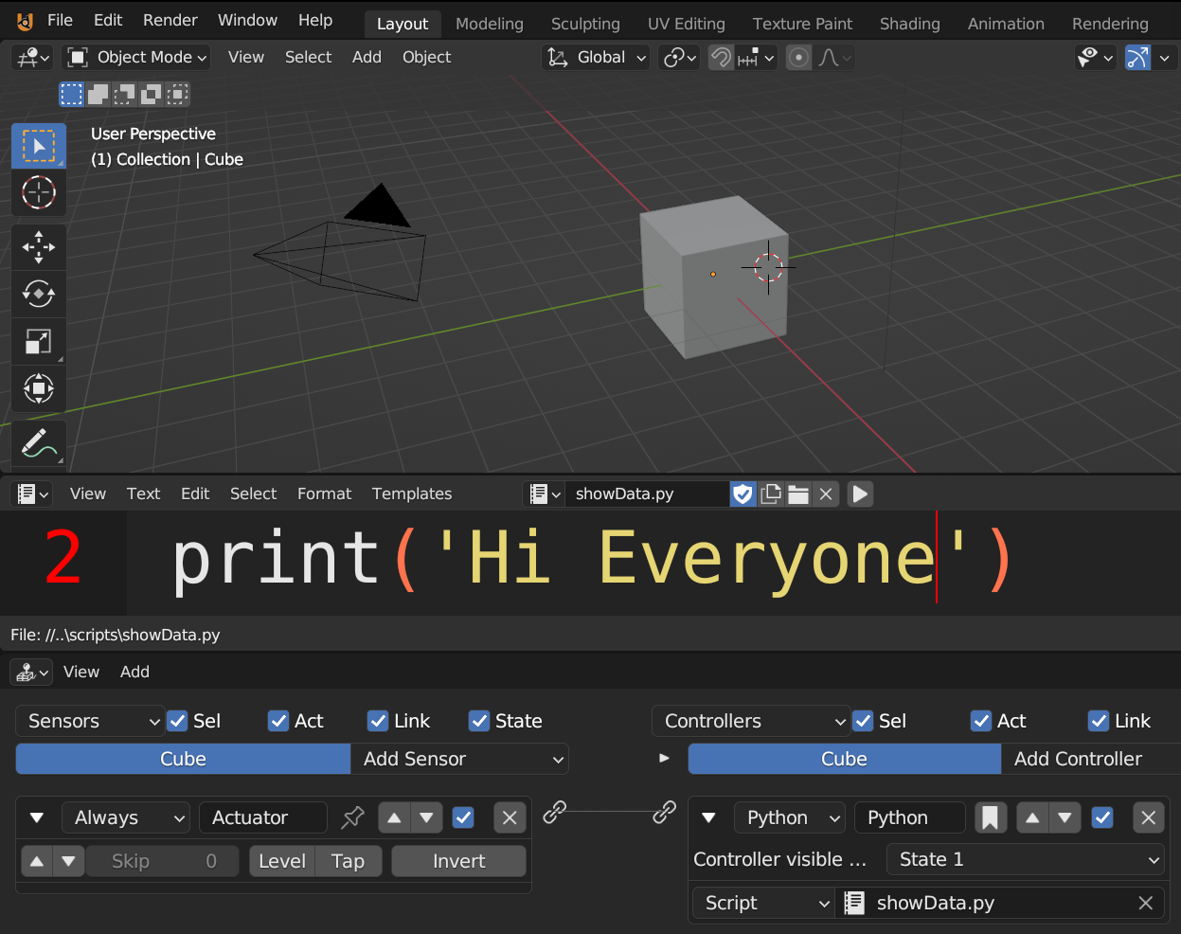
To Start the ENGINE, we press the letter: P
This begins the Blender Game Engine.
We make sure to have the Blender Console open to see the Hi Everyone Message and any other messages from our Game Making.
We End the ENGINE by pressing ESC

# show_object_name.py

# import blender game engine
import bge

# get controller running this script
controller = bge.logic.getCurrentController()

# get game object controller is on
obj = controller.owner

# show the data of the object
print(obj)

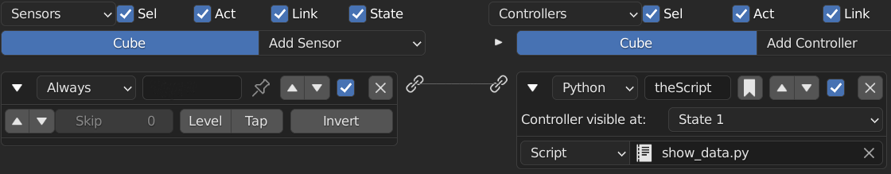
-

# Result
# Cube

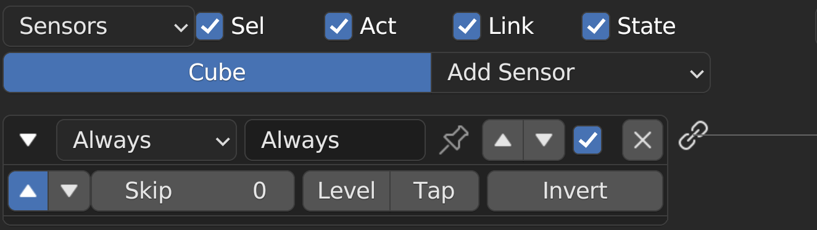
Zooming in, we see the Always Sensor

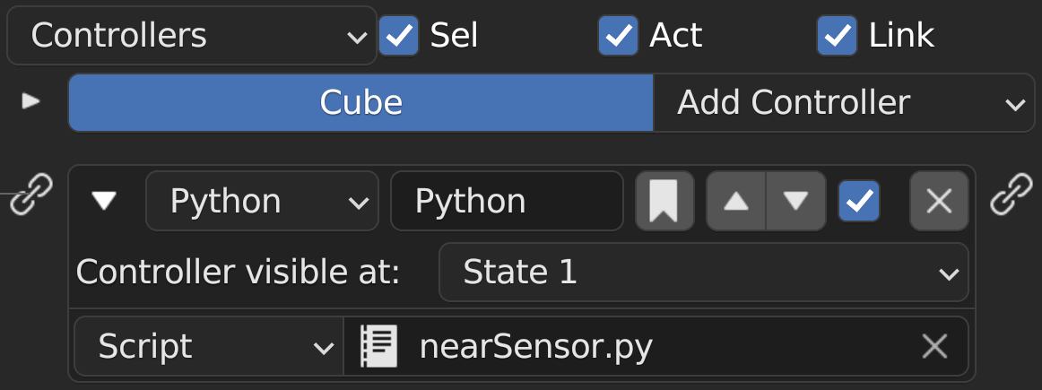

# show_name.py

# import the blender game engine
import bge

# get controller running this script
controller = bge.logic.getCurrentController()

# get game object controller is on
obj = controller.owner

# show the data of the object
print(obj.name)

#Result
#Cube

# show_name_with_label.py

# import the blender game engine
import bge

# get controller running this script
controller = bge.logic.getCurrentController()

# get game object controller is on
obj = controller.owner

# show the data of the object
print("Name: ", obj.name)

#Result
#Name is: Cube

# get_position.py

# import the blender game engine
import bge

# get controller running this script
controller = bge.logic.getCurrentController()

# get game object controller is on
obj = controller.owner

# show the location of the object
print(obj.position)

#Return
#<Vector (0.0000, 0.0000, 0.0000)>

# get_position_x.py

# import the blender game engine
import bge

# get controller running this script
controller = bge.logic.getCurrentController()

# get game object controller is on
obj = controller.owner

# show the location of the object
print(obj.position.x)

# 0.0000

# get_position_y.py

# import the blender game engine
import bge

# get controller running this script
controller = bge.logic.getCurrentController()

# get game object controller is on
obj = controller.owner

# show the location of the object
print(obj.position.y)

# 0.0000

# get_position_z.py

# import the blender game engine
import bge

# get controller running this script
controller = bge.logic.getCurrentController()

# get game object controller is on
obj = controller.owner

# show the location of the object
print(obj.position.z)

# Result
# 0.0000

# get_position_x_y_z.py

# import the blender game engine
import bge

# get controller running this script
controller = bge.logic.getCurrentController()

# get game object controller is on
obj = controller.owner

# show the location of the object
print(obj.position.x)
print(obj.position.y)
print(obj.position.z)

'''
0.0000
0.0000
0.0000
'''

# move_object_to_position_x_y_z.py

# import the blender game engine
import bge

# get controller running this script
controller = bge.logic.getCurrentController()

# get game object controller is on
obj = controller.owner

# move the object by xyz
obj.position.x = -3
obj.position.y = -3
obj.position.z = 3

print(obj.position)

'''
moves object to position of
<Vector (-3.0000, -3.0000, 3.0000)>
'''

# move_object_to_position_vector_xyz.py

# import the blender game engine
import bge

# get controller running this script
controller = bge.logic.getCurrentController()

# get game object controller is on
obj = controller.owner

# move the object to vector position
obj.position = (-3, -3, 3)

print(obj.position)

'''
moves object to position of
<Vector (-3.0000, -3.0000, 3.0000)>
'''

# move_object_in_increments.py

# import the blender game engine
import bge

# get controller running this script
controller = bge.logic.getCurrentController()

# get game object controller is on
obj = controller.owner

# move the object by 0.1
obj.position.x += 0.1

# moves object 0.1 pixels in the x direction

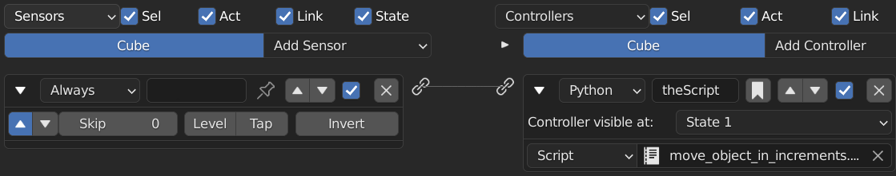
-

# Always Sensor pulse is set to positive

The Always Sensor triggers repeatedly at a set Skip rate, or just one time, if no pulse set

Activates every TRUE pulse of the game engine.

obj.position.x += 0.1

This means that every true pulse of the game engine, our Cube object will move on the x direction 0.1 meters.

If not selected, the always sensor will only activate one time upon start of the game.

# get_sensor.py

import bge

def main():
# get the current object
obj = bge.logic.getCurrentController().owner

# target object name for proximity check (make sure it exists in the scene)
target_name = "TargetObject"

scene = bge.logic.getCurrentScene()

target = scene.objects.get(target_name)

# define a "near" range
proximity_range = 25.0

if target:
# check if within range
is_near = obj.getDistanceTo(target) <= proximity_range

if is_near:
# if within proximity, apply movement
obj.applyMovement((0.2, 0, 0), True)
print("Target within range, moving object.")

main()

# show_mouse_arrow.py

# import the blender game engine
import bge

# get controller running this script
controller = bge.logic.getCurrentController()

# get game object controller is on
obj = controller.owner

# show mouse arrow
bge.render.showMouse(True)

# show_mouse_arrow_at_position.py

# import the blender game engine
import bge

# get controller running this script
controller = bge.logic.getCurrentController()

# get game object controller is on
obj = controller.owner

# show mouse arrow
bge.render.showMouse(True)

# set mouse arrow position
bge.render.setMousePosition(100, 250)

# world_position_rotation.py

import bge

controller = bge.logic.getCurrentController()

owner = controller.owner

owner.worldPosition.z += 0.1

# [x, y, z]
owner.applyRotation([0, 0, 0.1])

# text_change.py

import bge

controller = bge.logic.getCurrentController()

owner = controller.owner

owner['Text'] = 'Hi Everyone'

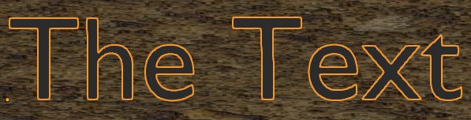
-

# text_change_other_object.py

import bge

theScene = bge.logic.getCurrentScene()

theScene.objects['theText']['Text'] = 'Howdy'

-

We connect the text object named theText to the object named ourPlayer
by Selecting first theText, holding shift and selecting ourPlayer, and then Holding Control + P to Set Parent To

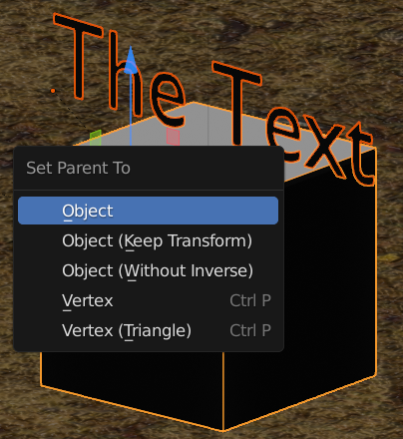
-

In the Blender Game Engine mode, when we begin our game in camera mode, we can now see our text attached to our object.
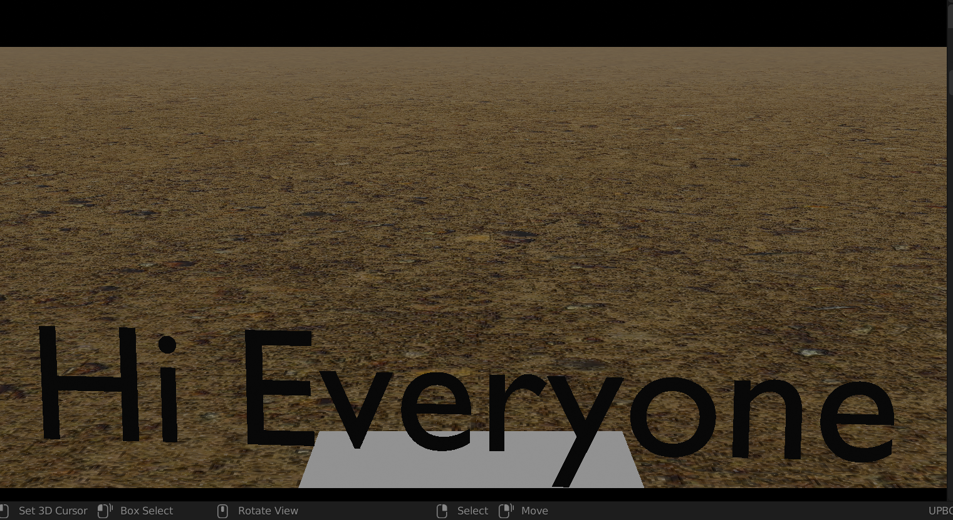

In this example we simply made ourPlayer object be the parent of the text object. Now the text stays with ourPlayer.

# property_change.py

import bge

theScene = bge.logic.getCurrentScene()

# we reference the object named coin,
# and the property it has named counter
ourCounter = theScene.objects['coin']['counter']

ourCounter = 5

theScene.objects['theText']['Text'] = ourCounter

The text object named theText will change
to the value of the counter property.

Move Object
Using
Python Script

# Move Object Using Python Near Sensor equivalent

import bge

def main():
# get controller running this script
controller = bge.logic.getCurrentController()

# get game object this script is attached to
obj = controller.owner

# get all objects in scene
scene = bge.logic.getCurrentScene()
objects = scene.objects

# check for proximity to another object
target_object_name = "TargetObject"

target_object = objects.get(target_object_name)

if target_object:
# calculate distance between objects
distance = (obj.worldPosition - target_object.worldPosition).length

# define threshold distance for triggering movement
threshold_distance = 10.0

# is if target within threshold distance
if distance < threshold_distance:
obj.position.x += 0.2
else:
obj.position.z += 1.2

main()

Player
Motion
Controls

# player_motion_controls.py

import bge

def main():
cont = bge.logic.getCurrentController()

own = cont.owner

keyboard = bge.logic.keyboard

wKey = bge.logic.KX_INPUT_ACTIVE == keyboard.events[bge.events.WKEY]

sKey = bge.logic.KX_INPUT_ACTIVE == keyboard.events[bge.events.SKEY]

aKey = bge.logic.KX_INPUT_ACTIVE == keyboard.events[bge.events.AKEY]

dKey = bge.logic.KX_INPUT_ACTIVE == keyboard.events[bge.events.DKEY]

if wKey:
own.applyMovement([0,0.2,0], True)
if sKey:
own.applyMovement([0,-0.2,0], True)
if aKey:
own.applyMovement([-0.2,0,0], True)
if dKey:
own.applyMovement([0.2,0,0], True)

main()

True Artificial Intelligence System

Tautology
1111
Contra-
-diction
0000
XOR
0110
XNOR
1001
AND
0001
NAND
1110
OR
0111
NOR
1000
MI
1101
MNI
0010
LP
0011
LC
1100
RP
0101
RC
1010
CI
1011
CNI
0100
16-Gon
For More Tutorials:

CollegeOfScripting.weebly.com

CollegeOfScripting.wordpress.com

GitHub.com/ChristopherTopalian

GitHub.com/ChristopherAndrewTopalian

Youtube.com/ScriptingCollege

Twitter.com/CollegeOfScript

Rumble.com/user/CollegeOfScripting

Sites.google.com/view/CollegeOfScripting

Dedicated to God the Father

This book is created by the
College of Scripting Music & Science.

Always remember, that each time you write a script with a pencil and paper, it becomes imprinted so deeply in memory that the material and methods are learned extremely well. When you Type the scripts, the same is true.

The more you type and write out the scripts by keyboard or pencil and paper, the more you will learn programming!

Write & Type EVERY example that you find.
Keep all of your scripts organized.
Every script that you create increases your programming abilities.

SEEING CODE, is one thing,
but WRITING CODE is another.
Write it, Type it, Speak it, See it, Dream it.

www.CollegeOfScripting.weebly.com

